INSTRUCTIONS TO INSTALL MYSQL

1. Go to the website: <https://dev.mysql.com/downloads/mysql/>
2. Download the ‘Windows (x86, 64-bit) MSI Installer

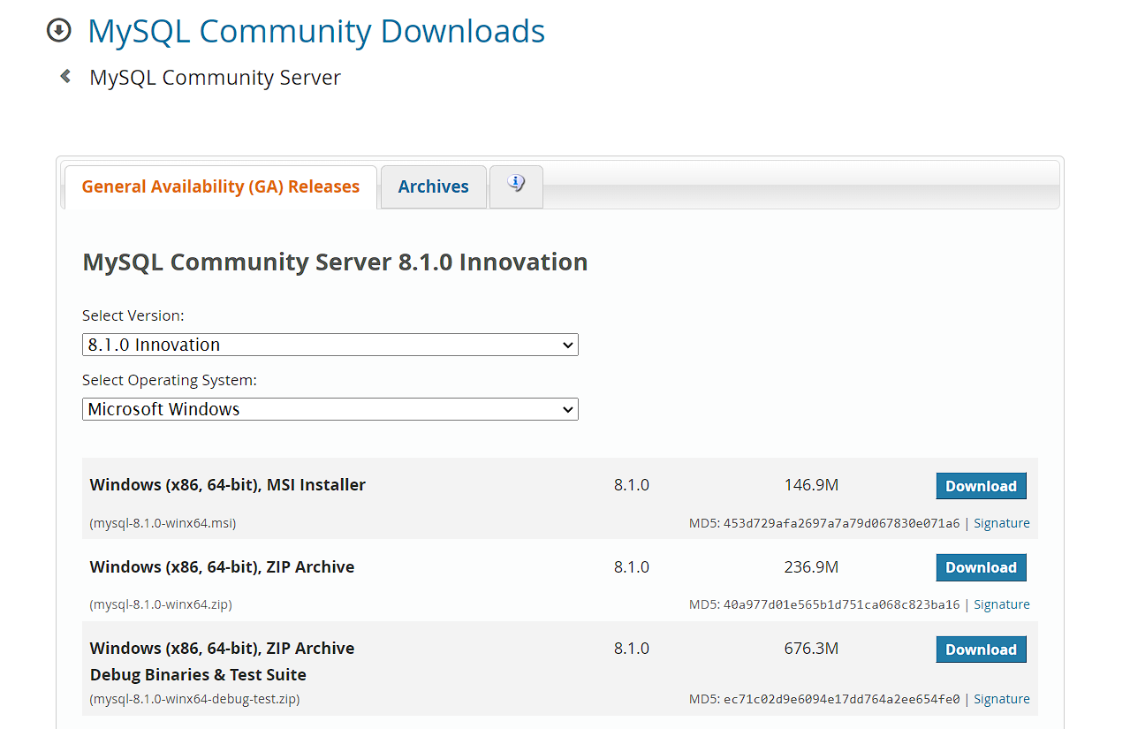

1. Double Click the downloaded file.
2. Click ***NEXT***
3. Check the checkbox and accept the agreement and click ***NEXT***
4. Click ***COMPLETE*** for installation of complete packages
5. Change the file path as you want
6. Click ***INSTALL***
7. MYSQL COMFIGURATOR opens
8. Click ***NEXT***

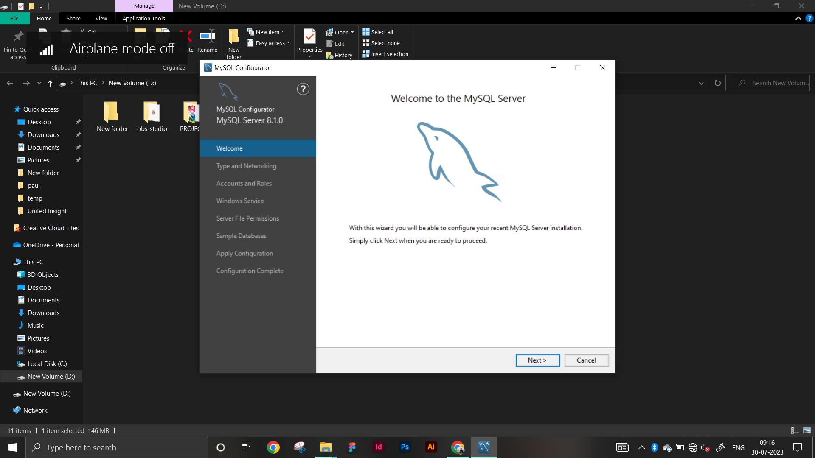

1. 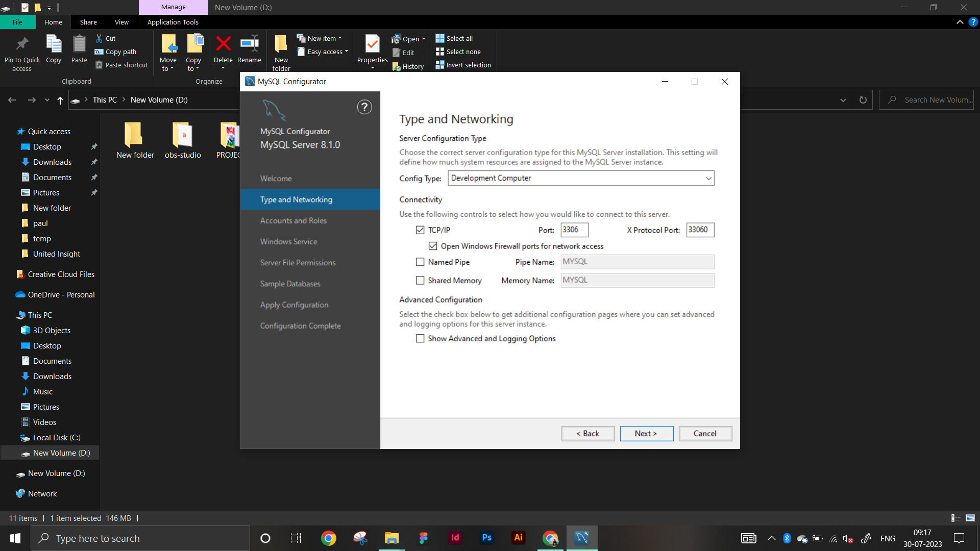
2. Click NEXT

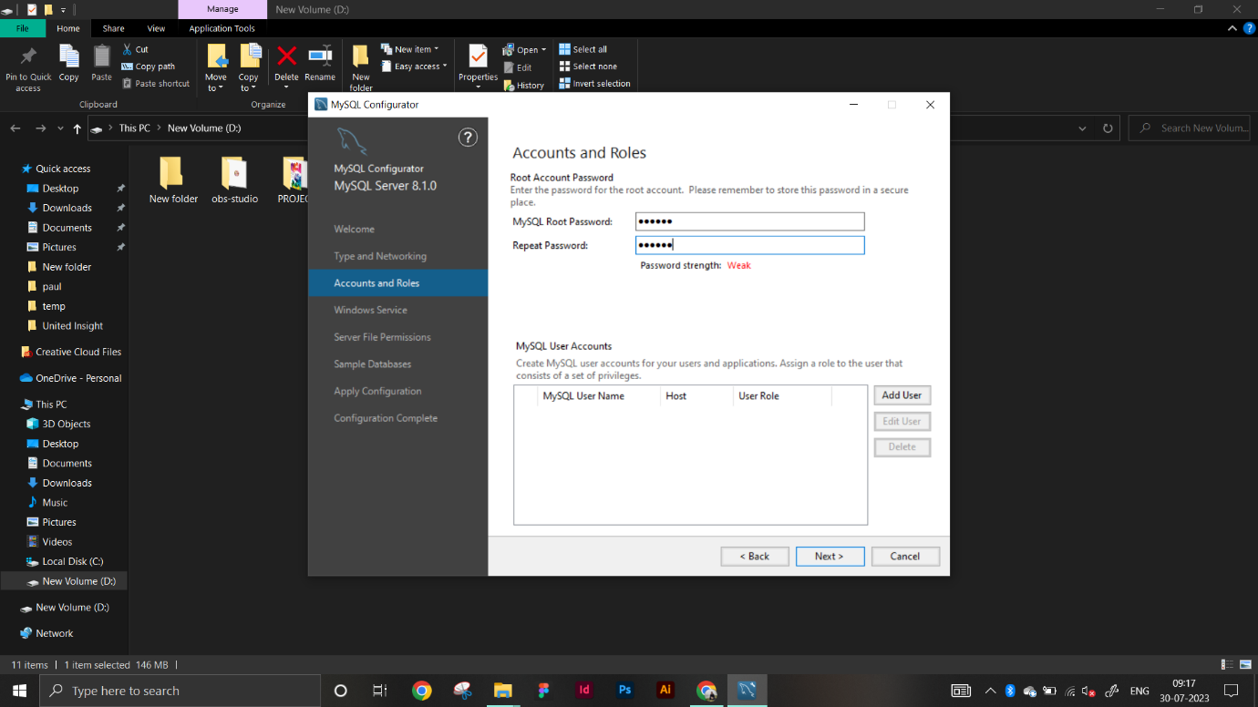

1. 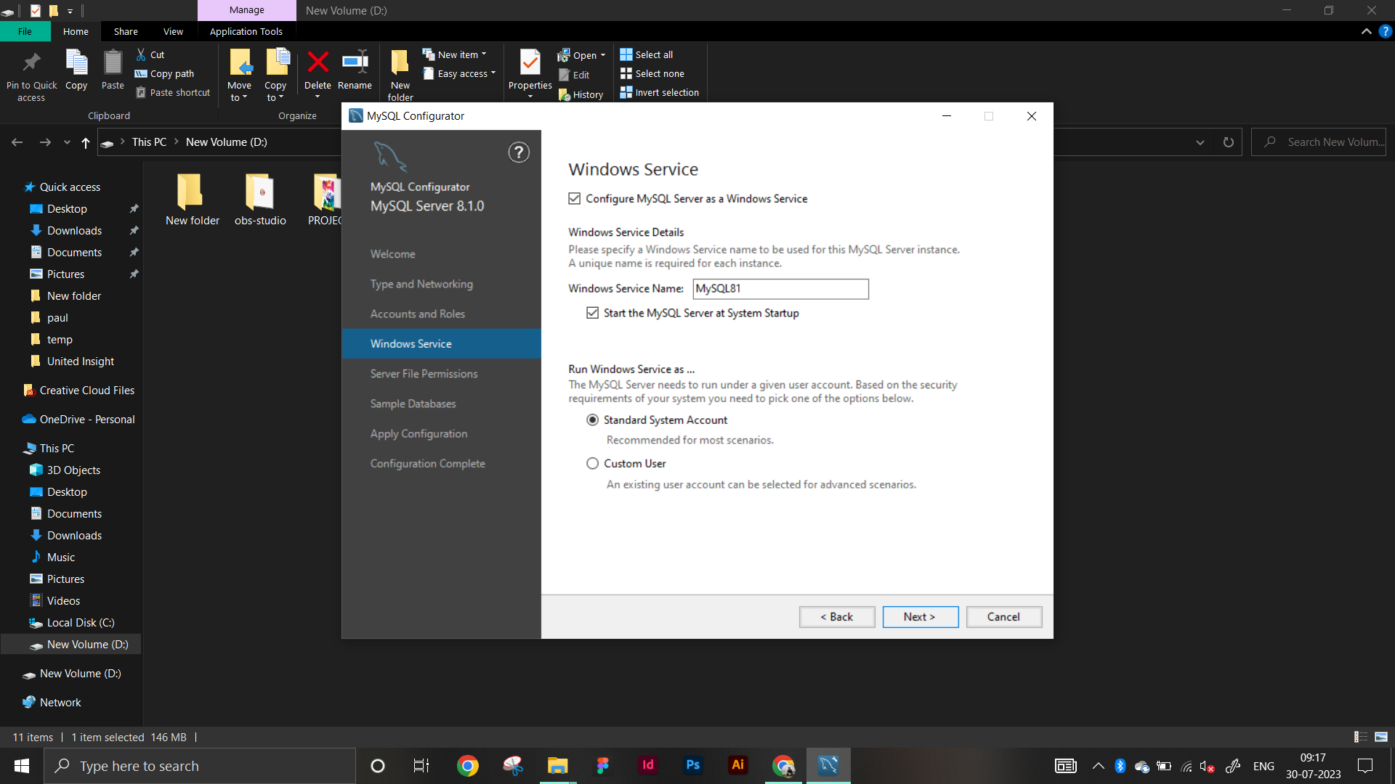Click NEXT
2. Click NEXT

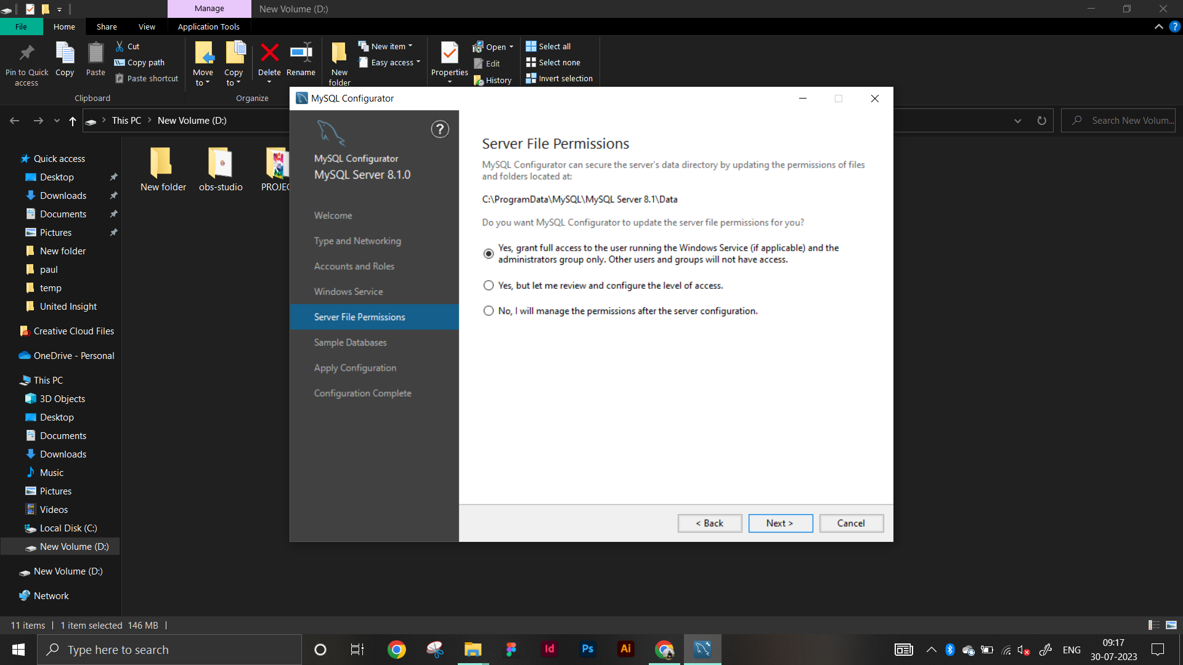

1. Click NEXT

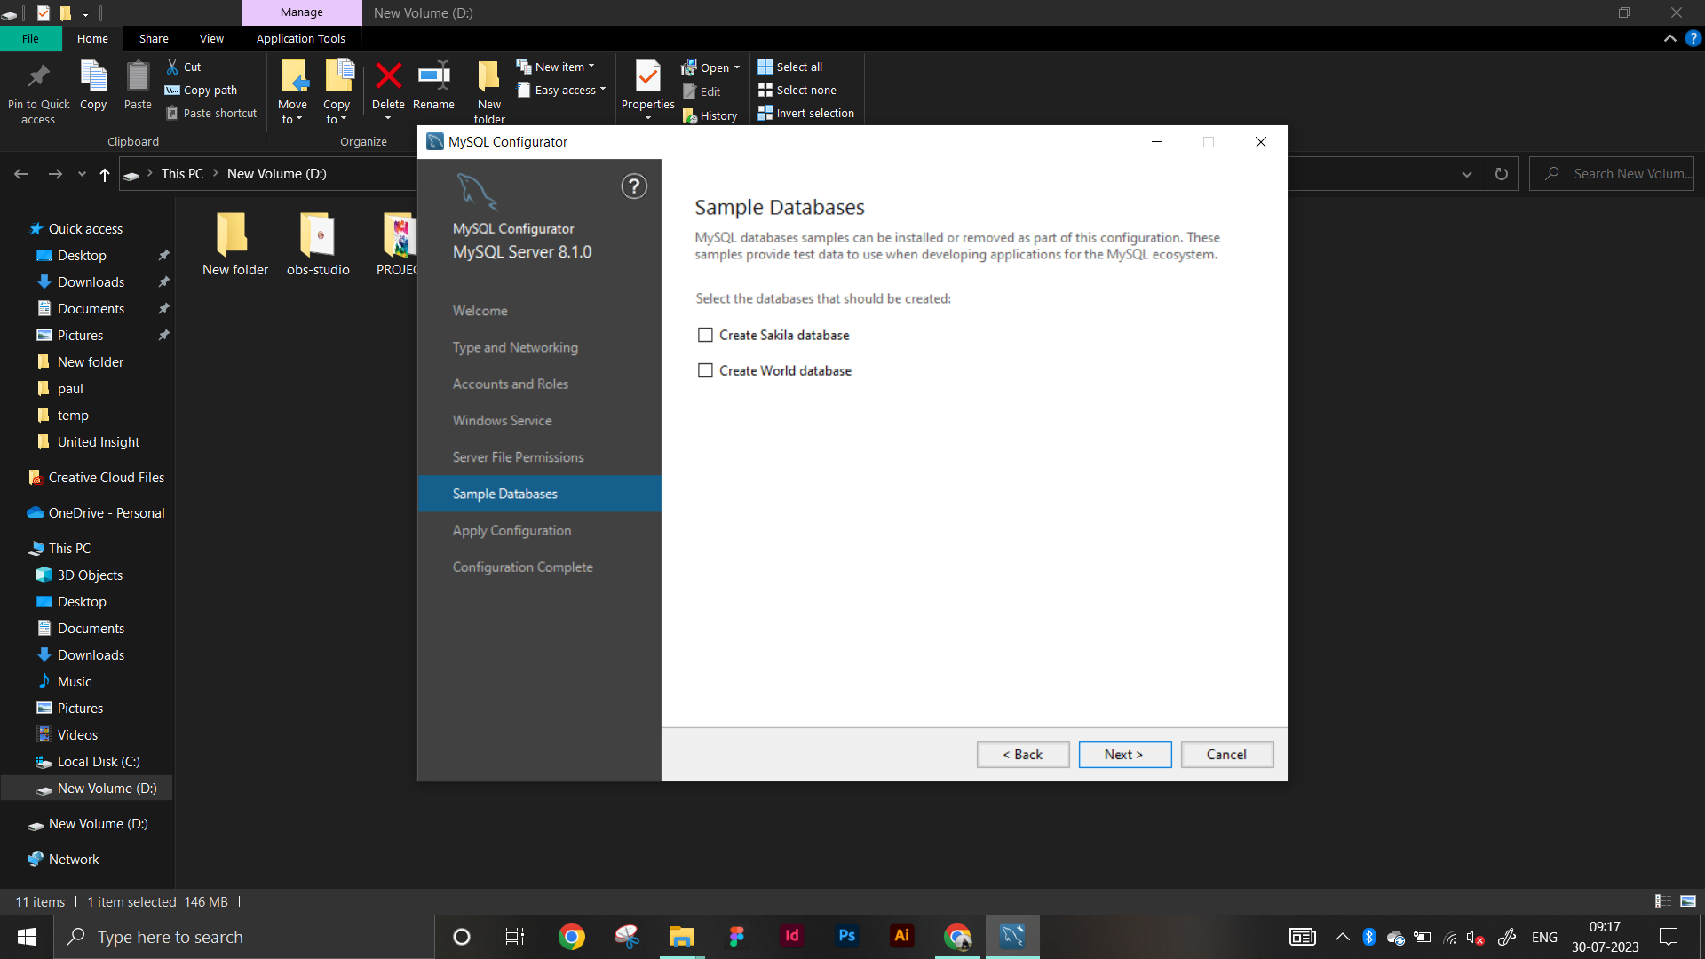

1. Click EXECUTE & then NEXT

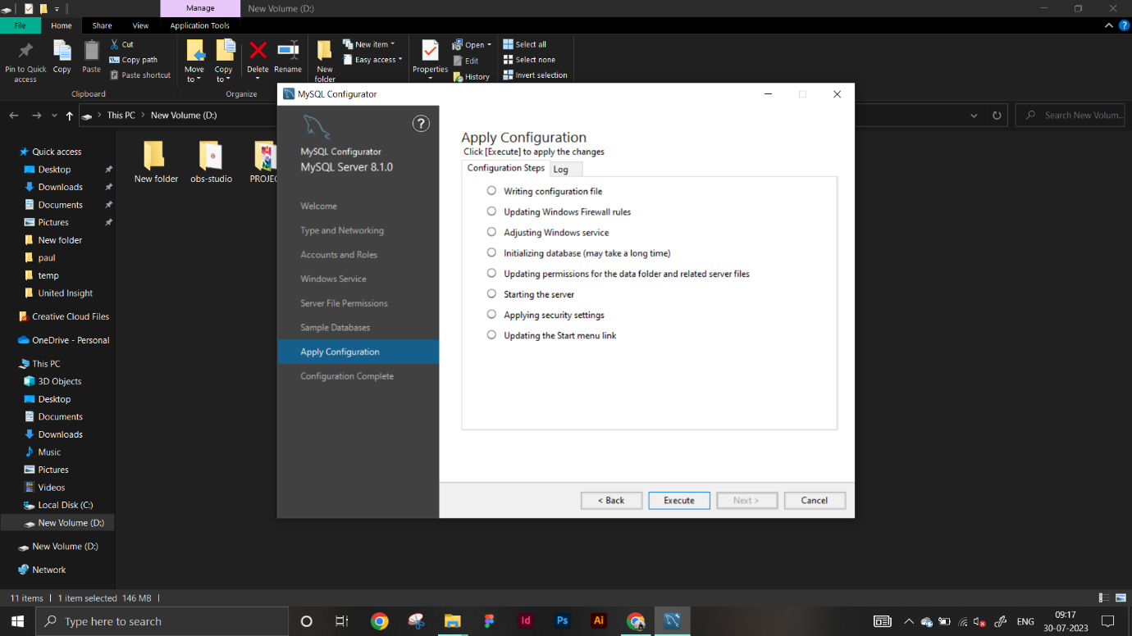

1. Click FINISH

